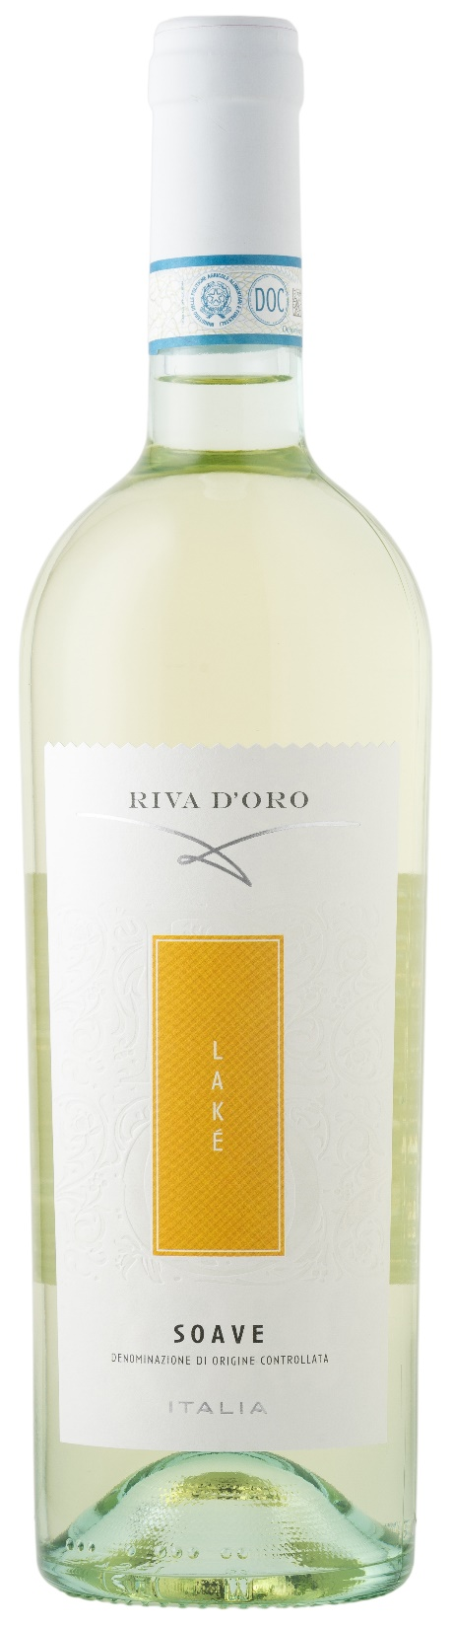
SOAVE DOC – LAKÈ

Grape: Garganega, Trebbiano
Alc. Vol.%: 12
Vintage: 2025
Residual sugar g/l: 4,0
Total acidity g/l: 5,4
Region: Veneto
Production zone: Vineyards in the Soave area
Capacity: 750ml, 1500ml

CHARACTERISTICS

Vinification: After a soft pressing and the separation of grape-stalk, the fermentation takes place in steel tanks at a controlled temperature
Aging: In steel tanks until bottling
Yield per ha: 15000kg
Colour: Lightly shiny straw-yellow
Bouquet: Fresh, with notes of exotic fruits
Flavour: Rich and harmonious

SERVING SUGGESTIONS

Best enjoyed with light starters, soups and fish dishes.
Serving temperature 8 °C
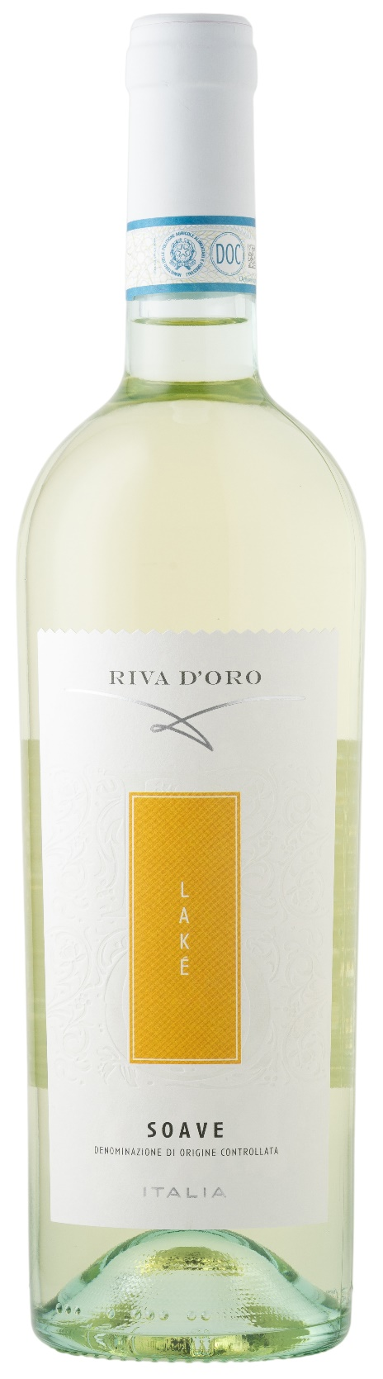
TECHNICAL INFORMATION / PALLETIZING

Size 750ml:
Article Nr. V09009A
GTIN-13 bottle 8017868000716
GTIN-13 carton 8017868004295
Closure Cork
Bottles / carton 6 bottles
Pallet size 80x120cm
Cartons/layer 21
Cartons/pallet 105
Kg/carton 7,8
Kg/pallet 840

Size 1500ml:
Article Nr. V09010B
GTIN-13 bottle 8017868000778
GTIN-13 carton 8017868004523
Closure Screwcap
Bottles / carton 6 bottles
Pallet size 80x120cm
Cartons/layer 14
Cartons/pallet 56
Kg/carton 13,5
Kg/pallet 780

Contains sulphites
GMO Free
Revisione 01. 14.05.2026

